**[CCNA 1 Final Exam V4.0 Answers](http://ccnaanswers.com/ccna-1-final-exam-v4-0-answers/)**

Posted in [CCNA 1 - Network Fundamentals (V4.0)](http://ccnaanswers.com/category/ccna-1-network-fundamentals/) - 5 April 2010 - 11 comments - 366,147 views

**1**.

[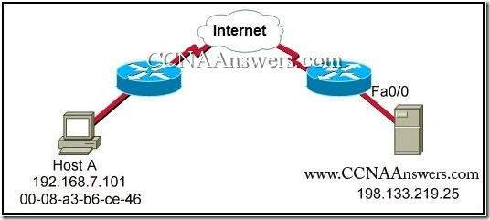](http://ccnaanswers.com/wp-content/uploads/CCNA1FinalExamV4.0Answers1.jpg)

Refer to the exhibit. What is the correct destination socket number for a web page request from Host A to the web server?

00-08-a3-b6-ce-46

198.133.219.25:80

<http://www.CCNAAnswers.com>

C 198.133.219.0/24 is directly connected, FastEthernet0/0

**2**. Which prompt represents the appropriate mode used for the **copy running-config startup-config** command ?

Switch-6J>

Switch-6J#

Switch-6J(config)#

Switch-6J(config-if)#

Switch-6J(config-line)#

**3**. Due to a security violation, the [router](http://ccnaanswers.com/) passwords must be changed. What information can be learned from the following configuration entries? (Choose two)

Router(config)# **line vty 0 3**Router(config-line)# **password c13c0**   
Router(config-line)# **login**

The entries specify three Telnet lines for remote access.

The entries specify four Telnet lines for remote access.

The entries set the console and Telnet password to “c13c0″.

Telnet access will be denied because the Telnet configuration is incomplete.

Access will be permitted for Telnet using “c13c0″ as the password.

**4**.

[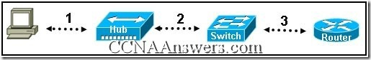](http://ccnaanswers.com/wp-content/uploads/CCNA1FinalExamV4.0Answers2.jpg)

Refer to the exhibit. Each media link is labeled. What type of cable should be used to connect the different devices?

Connection 1 – rollover cable   
Connection 2 – straight-through cable   
Connection 3 – crossover cable

Connection 1 – crossover cable   
Connection 2 – rollover cable   
Connection 3 – crossover cable

Connection 1 – straight-through cable   
Connection 2 – crossover cable   
Connection 3 – crossover cable

Connection 1 – straight-through cable   
Connection 2 – crossover cable   
Connection 3 – straight-through cable

Connection 1 – crossover cable   
Connection 2 – straight-through cable   
Connection 3 – crossover cable

**5**.

[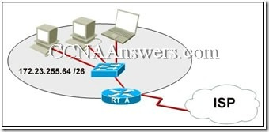](http://ccnaanswers.com/wp-content/uploads/CCNA1FinalExamV4.0Answers3.jpg)

Refer to the exhibit. What function does router RT_A need to provide to allow Internet access for hosts in this network?

address translation

DHCP services

ftpd

web server

**6**. When connectionless protocols are implemented at the lower layers of the OSI model, what is usually used to acknowledge that the data was received and to request the retransmission of missing data?

IP

UDP

Ethernet

a connectionless acknowledgement

an upper-layer, connection-oriented protocol or service

**7**.

[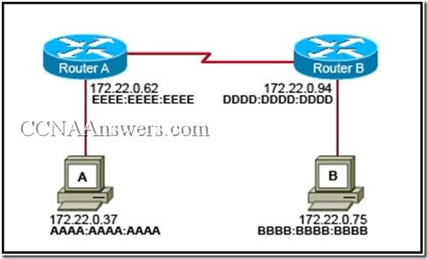](http://ccnaanswers.com/wp-content/uploads/CCNA1FinalExamV4.0Answers4.jpg)

Refer to the exhibit. Host A is transmitting data to host B. What addresses will host A use to for the destination IP and MAC addresses in this communication?

Destination MAC: BBBB:BBBB:BBBB Destination IP: 172.22.0.62

Destination MAC: DDDD:DDDD:DDDD Destination IP: 172.22.0.75

Destination MAC: EEEE:EEEE:EEEE Destination IP: 172.22.0.62

Destination MAC: BBBB:BBBB:BBBB Destination IP: 172.22.0.75

Destination MAC: EEEE:EEEE:EEEE Destination IP: 172.22.0.75

Destination MAC: DDDD:DDDD:DDDD Destination IP: 172.22.0.94

**8**.

[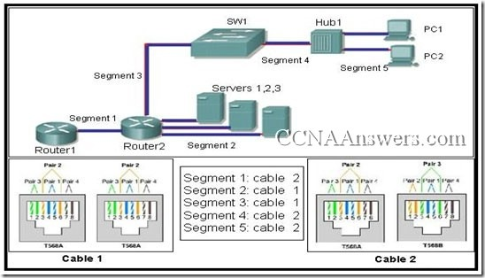](http://ccnaanswers.com/wp-content/uploads/CCNA1FinalExamV4.0Answers5.jpg)

Refer to the exhibit. Cable 1 and cable 2 have the ends wired for specific physical layer requirements. The table lists each segment by number and the cable which has been installed by the network technician between the network components on that segment. From the data given, which segments have the correct cable installed? (Choose three.)

segment1

segment2

segment3

segment4

segment5

**9**. What is true regarding network layer addressing? (Choose three)

uses a flat structure

prevent broadcasts

heirarchical

uniquely identifies each host

48 bits in length

contains a network portion

**10**.

[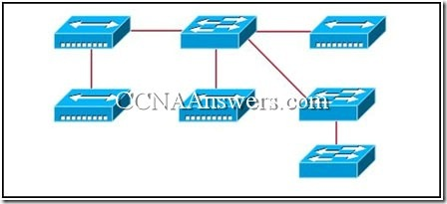](http://ccnaanswers.com/wp-content/uploads/CCNA1FinalExamV4.0Answers6.jpg)

Refer to the exhibit. What two facts can be determined about the exhibited topology? (Choose two)

A single broadcast domain is present

Two logical address ranges are required.

Three broadcast domains are shown.

Four networks are needed.

Five collision domains exist

**11**.

[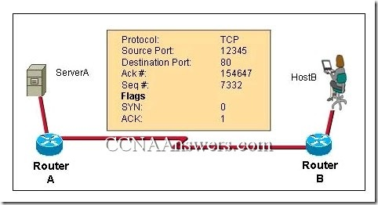](http://ccnaanswers.com/wp-content/uploads/CCNA1FinalExamV4.0Answers26.jpg)

Refer to the exhibit. What two facts can be determined from the information that is given? (Choose two.)

This exchange is part of the three-way handshake.

The source port indicates that a Telnet session has been initiated.

The data is flowing from server to client.

The destination port indicates that an HTTP session has been initiated.

The data listed is associated with the transport layer.

The source port does not support communication with the destination port that is listed.

**12**. In a Cisco IOS device, where is the startup-configuration file stored?

Flash

NVRAM

RAM

ROM

**13**.

[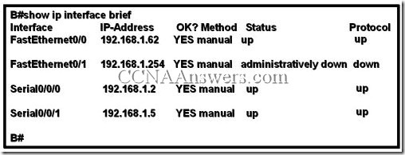](http://ccnaanswers.com/wp-content/uploads/CCNA1FinalExamV4.0Answers7.jpg)

Refer to the exhibit. The network containing router B is experiencing problems. A network associate has isolated the issue in this network to router B. What action can be preformed to correct the network issue?

issue the clock rate command on interface Serial 0/0/0

issue the description command on interface Serial 0/0/1

issue the ip address command on interface FastEthernet 0/0

issue the no shutdown command on interface FastEthernet 0/1

**14**.

[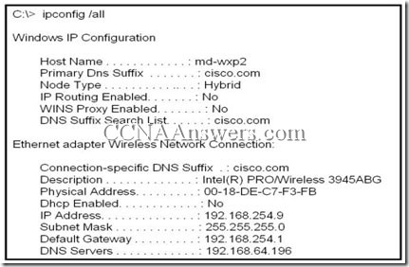](http://ccnaanswers.com/wp-content/uploads/CCNA1FinalExamV4.0Answers8.jpg)

Refer to the exhibit. A technician is working on a network problem that requires verification of the router LAN interface. What address should be pinged from this host to confirm that the router interface is operational?

127.0.0.1

192.168.64.196

192.168.254.1

192.168.254.9

192.168.254.254

**15**. Which combination of network id and subnet mask correctly identifies all IP addresses from 172.16.128.0 through 172.16.159.255?

172.16.128.0 255.255.255.224

172.16.128.0 255.255.0.0

172.16.128.0 255.255.192.0

172.16.128.0 255.255.224.0

172.16.128.0 255.255.255.192

**16**.

[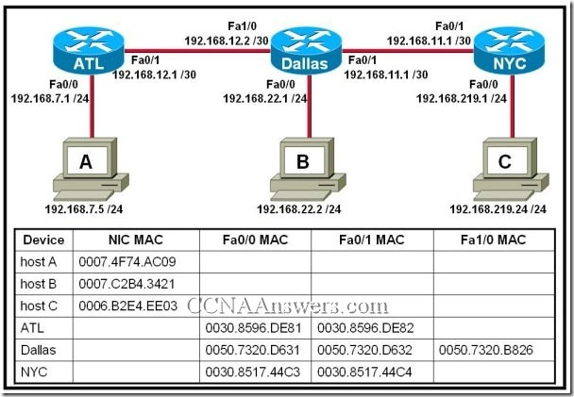](http://ccnaanswers.com/wp-content/uploads/CCNA1FinalExamV4.0Answers9.jpg)

Refer to the exhibit. Host A attempts to establish a TCP/IP session with host C. During this attempt, a frame was captured with the source MAC address 0050.7320.D632 and the destination MAC address 0030.8517.44C4. The packet inside the captured frame has an IP source address 192.168.7.5, and the destination IP address is 192.168.219.24. At which point in the network was this packet captured?

leaving host A

leaving ATL

leaving Dallas

leaving NYC

**17**.

[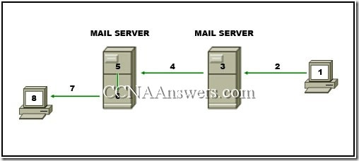](http://ccnaanswers.com/wp-content/uploads/CCNA1FinalExamV4.0Answers10.jpg)

Refer to the exhibit. The diagram represents the process of sending email between clients. Select the list below that correctly identifies the component or protocol used at each numbered stage of the diagram.

1.MUA 2.MDA 3.MTA 4.SMTP 5.MTA 6.POP 7.MDA 8.MUA

1.MUA 2.POP 3.MDA 4.SMTP 5.MTA 6.MDA 7.SMTP 8.MUA

1.MUA 2.POP 3.SMTP 4.MDA 5.MTA 6.SMTP 7.POP 8.MUA

1.MDA 2.SMTP 3.MTA 4.SMTP 5.MTA 6.MUA 7.POP 8.MDA

1.MUA 2.SMTP 3.MTA 4.SMTP 5.MTA 6.MDA 7.POP 8.MUA

**18**.

[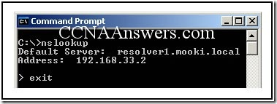](http://ccnaanswers.com/wp-content/uploads/CCNA1FinalExamV4.0Answers11.jpg)

Refer to the exhibit. The command that is shown was issued on a PC. What does the IP address 192.168.33.2 represent?

IP address of the host

default gateway of the host

IP address of the homepage for the host

primary domain name server for the host

IP address of the website resolver1.mooki.local

**19**.

[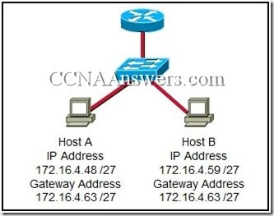](http://ccnaanswers.com/wp-content/uploads/CCNA1FinalExamV4.0Answers12.jpg)

Refer to the exhibit. On the basis of the IP configuration that is shown, what is the reason that Host A and Host B are unable to communicate outside the local network?

Host A was assigned a network address.

Host B was assigned a multicast address.

Host A and Host B belong to different networks.

The gateway address was assigned a broadcast address.

**20**.

[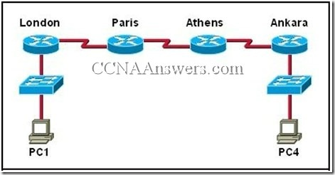](http://ccnaanswers.com/wp-content/uploads/CCNA1FinalExamV4.0Answers13.jpg)

Refer to the exhibit. The tracert command is initiated from PC1 to PC4. Which device will send a response to the initial tracert packet from PC1?

Athens

Ankara

London

Paris

PC4

**21**. Which password is automatically encrypted when it is created?

vty

aux

console

enable secret

enable password

**22**. Which OSI layer does IP rely on to determine whether packets have been lost and to request retransmission?

application

presentation

session

transport

**23**.

[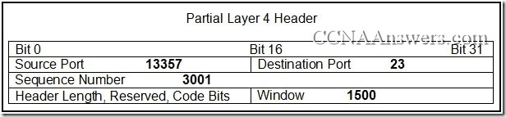](http://ccnaanswers.com/wp-content/uploads/CCNA1FinalExamV4.0Answers14.jpg)

Refer to the exhibit. Which two statements describe the information that is represented in the header? (Choose two)

This is a server response.

The UDP protocol is being used.

The destination port indicates a Telnet session.

The return segment will contain a source port of 23.

The next session originated from the client of this session will use the source port number 13358.

**24**. The Layer 4 header contains which type of information to aid in the delivery of data?

service port number

host logical address

device physical address

virtual connection identifier

**25**. As network administrator, what is the subnet mask that allows 510 hosts given the IP address 172.30.0.0?

255.255.0.0

255.255.248.0

255.255.252.0

255.255.254.0

255.255.255.0

255.255.255.128

**26**. When must a router serial interface be configured with the clock rate command?

when the interface is functioning as a DTE device

when the interface timers have been cleared

when the connected DTE device is shut down

when the interface is functioning as a DCE device

**27**.

[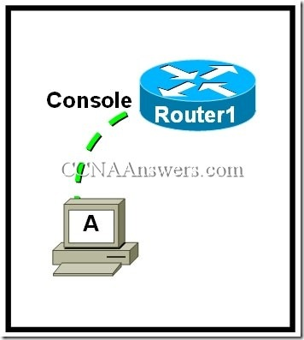](http://ccnaanswers.com/wp-content/uploads/CCNA1FinalExamV4.0Answers15.jpg)

Refer to the exhibit. What is required on host A for a network technician to create the initial configuration on Router1?

an FTP client

a Telnet client

a terminal emulation program

a web browser

**28**.

[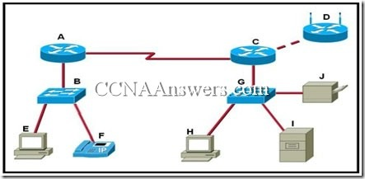](http://ccnaanswers.com/wp-content/uploads/CCNA1FinalExamV4.0Answers16.jpg)

Refer to the exhibit. Which set of devices contains only intermediary devices?

A, B, D, G

A, B, E, F

C, D, G, I

G, H, I, J

**29**.

[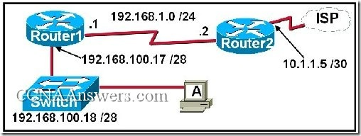](http://ccnaanswers.com/wp-content/uploads/CCNA1FinalExamV4.0Answers17.jpg)

Refer to the exhibit. A network technician is trying to determine the correct IP address configuration for Host A. What is a valid configuration for Host A?

IP address: 192.168.100.19; Subnet Mask: 255.255.255.248; Default Gateway: 192.16.1.2

IP address: 192.168.100.20; Subnet Mask: 255.255.255.240; Default Gateway: 192.168.100.17

IP address: 192.168.100.21; Subnet Mask: 255.255.255.248; Default Gateway: 192.168.100.18

IP address: 192.168.100.22; Subnet Mask: 255.255.255.240; Default Gateway: 10.1.1.5

IP address: 192.168.100.30; Subnet Mask: 255.255.255.240; Default Gateway: 192.168.1.1

IP address: 192.168.100.31; Subnet Mask: 255.255.255.240; Default Gateway: 192.168.100.18

**30**. A routing issue has occurred in you internetwork. Which of the following type of devices should be examined to isolate this error?

access point

host

hub

router

switch

**31**. Which type of media is immune to EMI and RFI? (Choose two.)

10 Base-T

10 Base-2

10 Base-5

100 Base-FX

100 Base TX

1000 Base LX

**32**.

[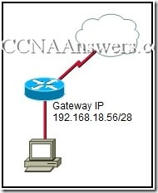](http://ccnaanswers.com/wp-content/uploads/CCNA1FinalExamV4.0Answers18.jpg)

Refer to the exhibit. With the router running NAT, what IP addresses can be applied to the computer to allow access to the Internet? (Choose three)

192.168.18.38

192.168.18.48

192.168.18.49

192.168.18.52

192.168.18.59

192.168.18.63

**33**. Which three IPv4 addresses represent a broadcast for a subnet? (Choose three.)

172.16.4.63 /26

172.16.4.129 /26

172.16.4.191 /26

172.16.4.51 /27

172.16.4.95 /27

172.16.4.221 /27

**34**.

[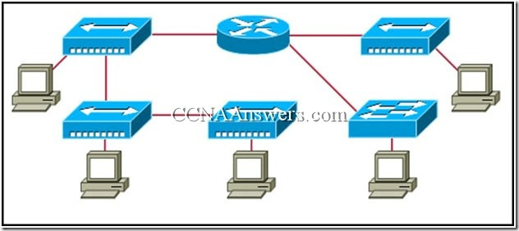](http://ccnaanswers.com/wp-content/uploads/CCNA1FinalExamV4.0Answers19.jpg)

Refer to the exhibit. Assume all devices are using default configurations. How many subnets are required to address the topology that is shown?

1

3

4

5

7

**35**. What are three characteristics of CSMA/CD? (Choose three)

Devices can be configured with a higher transmission priority.

A jam signal indicates that the collision has cleared and the media is not busy.

A device listens and waits until the media is not busy before transmitting.

The device with the electronic token is the only one that can transmit after a collision.

All of the devices on a segment see data that passes on the network medium.

After detecting a collision, hosts can attempt to resume transmission after a random time delay has expired.

**36**. A technician is asked to secure the privileged EXEC mode of a switch by requiring a password. Which type of password would require this login and be considered the most secure?

console

enable

enable secret

VTY

**37**. A PC can not connect to any remote websites, ping its default gateway, or ping a printer that is functioning properly on the local network segment. Which action will verify that the TCP/IP stack is functioning correctly on this PC?

Use the ipconfig /all command at the host’s command prompt.

Use the ping 127.0.0.1 command at the command prompt.

Use the traceroute command at the command prompt to identify any failures on the path to the gateway.

Use FTP to check for connectivity to remote sites.

Download a troubleshooting tool from the PC manufacturer’s website.

**38**.

[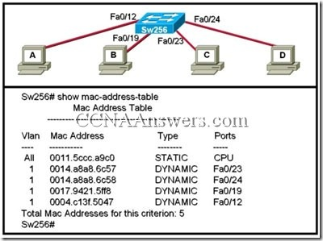](http://ccnaanswers.com/wp-content/uploads/CCNA1FinalExamV4.0Answers20.jpg)

Refer to the exhibit. When computer A sends a frame to computer D, what computers receive the frame?

only computer D

only computer A and computer D

only computer B, computer C, and computer D

all computers

**39**.

[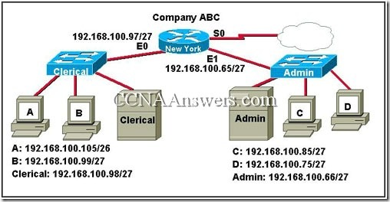](http://ccnaanswers.com/wp-content/uploads/CCNA1FinalExamV4.0Answers21.jpg)

Examine the graphic with current configurations. Host A in the Clerical offices failed and was replaced. Although a ping to 127.0.0.1 was successful, the replacement computer can not access the company network. What is the likely cause of the problem?

IP address incorrectly entered

network cables unplugged

subnet mask incorrectly entered

network card failure

**40**. Which two functions of the OSI model occur at layer two? (Choose two.)

physical addressing

encoding

routing

cabling

media access control

**41**.

[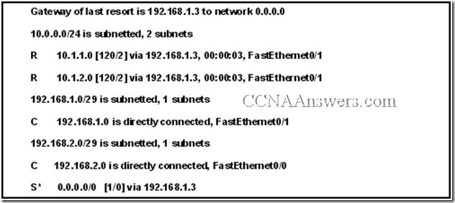](http://ccnaanswers.com/wp-content/uploads/CCNA1FinalExamV4.0Answers22.jpg)

Refer to the exhibit. A router, whose table is shown, receives a packet that is destined for 192.168.1.4. How will router treat the packet?

The packet will be dropped.

The packet will be forwarded via FastEthernet 0/0.

The packet will be forwarded to the destination host.

The packet will be forwarded to the 192.168.1.3 next-hop address.

**42**. Which range of port numbers are reserved for services that are commonly used by applications that run on servers?

0 to 255

0 to 1023

1024 to 49151

49152 to 65535

**43**.

[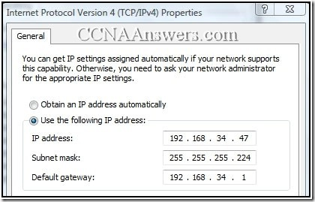](http://ccnaanswers.com/wp-content/uploads/CCNA1FinalExamV4.0Answers23.jpg)

Refer to the exhibit. What three statements are true about the IP configuration that is shown? (Choose three.)

The address that is assigned to the computer represents private addressing.

The computer is unable to communicate outside of the local network.

The network of this computer can have 126 hosts.

The prefix of the computer address is /27.

The IP address that is assigned to the computer is routable on the Internet.

The IP address that is assigned to the computer is a broadcast address.

**44**.

[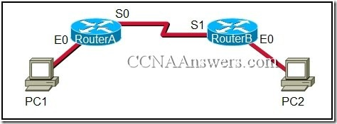](http://ccnaanswers.com/wp-content/uploads/CCNA1FinalExamV4.0Answers24.jpg)

Refer to the exhibit. A network administrator remotely accesses the CLI of RouterB from PC1 using Telnet. Which statement is true about this connection?

The data is automatically encrypted.

A Telnet server process is running on PC1.

The connection is made through a VTY session on the router.

A GET request was sent to RouterB to retrieve data during this session.

**45**. Which three statements characterize the transport layer protocols? (Choose three.)

TCP and UDP port numbers are used by application layer protocols.

TCP uses port numbers to provide reliable transportation of IP packets.

UDP uses windowing and acknowledgments for reliable transfer of data.

TCP uses windowing and sequencing to provide reliable transfer of data.

TCP is a connection-oriented protocol. UDP is a connectionless protocol.

**46**. Which of the following are the address ranges of the private IP addresses? (Choose three.)

10.0.0.0 to 10.255.255.255

200.100.50.0 to 200.100.25.255

150.150.0.0 to 150.150.255.255

172.16.0.0 to 172.31.255.255

192.168.0.0 to 192.168.255.255

127.16.0.0 to 127.31.255.255

**47**. Which OSI layers offers reliable, connection-oriented data communication services?

application

presentation

session

transport

network

**48**.

[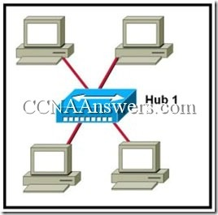](http://ccnaanswers.com/wp-content/uploads/CCNA1FinalExamV4.0Answers25.jpg)

Refer to the exhibit. Which logical topology best describes the exhibited network?

star

ring

point-to-point

multiaccess

mesh

**49**. During the encapsulation process, which identifiers are added at the transport layer?

two networks routing the packets

two applications communicating the data

two hosts at either end of the communication

two nodes on the local network exchanging the frame

**50**. What are two characteristics of the data link layer? (Choose two.)

It segments and reorders the data.

It exchanges the frames between nodes.

It defines the method by which network devices place data onto the media.

It manages the transfer of data between the processes that run on each host.